

Technisch Design

IN102_2



17 september 2014

ITOPIA

Duivendrechtsekade 8 Amsterdam

|  |  |  |
| --- | --- | --- |
| **Versiebeheer** | | |
| Versie nr. | Datum | Opmerkingen |
| 1.0 |  |  |
|  |  |  |
|  |  |  |

Table of Contents

Inleiding 3

Technische tekening 0

Hardware specificatie 0

Router 0

Server 0

Acces points 0

Dhcp- en DNS service 1

Tomcat software 1

Protocollen 1

IP plan 1

# Inleiding

Dit document bevat de technische configuratie van de hardware componenten van het ontwerp.  
ook tekeningen, schema’s en tabellen.

# Technische tekening

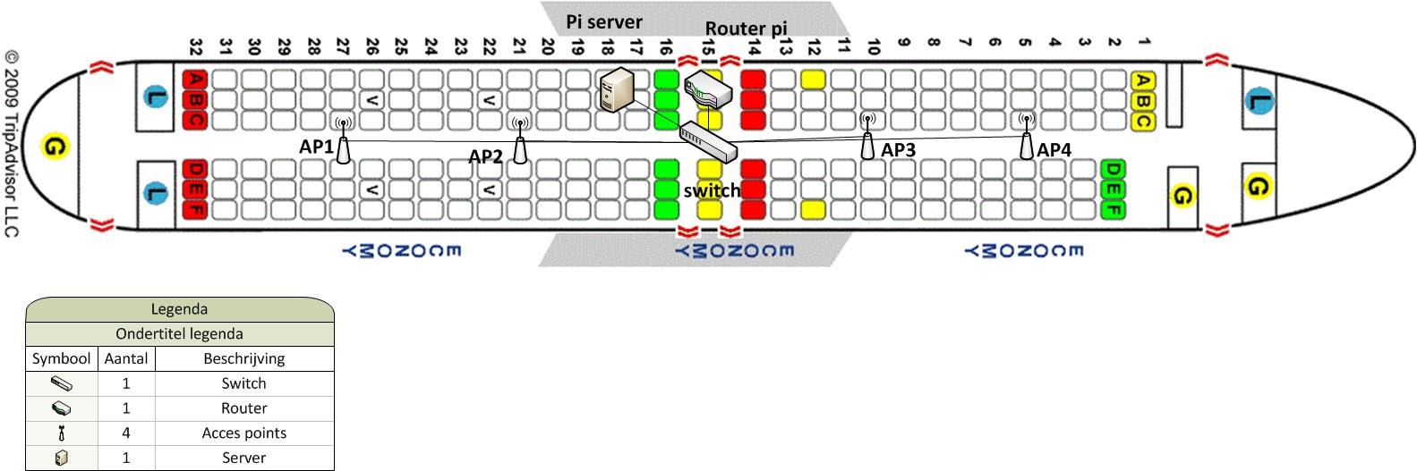

# Hardware specificatie

## Router

|  |  |
| --- | --- |
| Raspberry Pi |  |
| Naam | **Pi router** |
| SOC | Broadcom BCM2835 (CPU + GPU + DSP) |
| CPU | 700 MHz ARM1176JZF-S core |
| RAM | 512MB |
| Geheugen | SD-Card Dynamische grote |
| Opslag | 4,8,16 GB |
| OS | Raspian Wheezy |
| IP-addres | x.x.x.x |
| Opmerkingen |  |

## Server

|  |  |
| --- | --- |
| Raspberry Pi |  |
| Naam | **Server pi** |
| SOC | Broadcom BCM2835 (CPU + GPU + DSP) |
| CPU | 700 MHz ARM1176JZF-S core |
| RAM | 512MB |
| Geheugen | SD-Card Dynamische grote |
| Opslag | 4,8,16 GB |
| OS | Raspian Wheezy |
| IP-addres | x.x.x.x |
| Opmerkingen | Captive portal, dhcp, dns, IPtables |

## Acces points

|  |  |
| --- | --- |
| Raspberry Pi |  |
| Naam | **Accespoint(x) x=nummer** |
| SOC | Broadcom BCM2835 (CPU + GPU + DSP) |
| CPU | 700 MHz ARM1176JZF-S core |
| RAM | 512MB |
| Geheugen | SD-Card Dynamische grote |
| Opslag | 4,8,16 GB |
| OS | Raspian Wheezy |
| IP-addres | x.x.x.x |
| Opmerkingen |  |

# Dhcp- en DNS service

|  |  |  |
| --- | --- | --- |
| **Items Waarde** | | **Configuratie** |
| **DNS servers** |  |  |
| **Domein zone** |  |  |
| **Forward lookup** |  |  |
| **Reverse lookup** |  |  |
| **Opmerkingen** |  | |

|  |  |  |
| --- | --- | --- |
| **Items Waarde** | | **Configuratie** |
| **Scope naam** | Corendon Wi-fi |  |
| **Start IP** | 192.168.1.x |  |
| **Eind IP** | 192.168.1.x |  |
| **Subnetmask** | 255.255.255.0 |  |
| **Duration** | Lease time 4 Hours |  |
| **Scope options** | Router  Dns server  Dns domain server  Time server | DNS:  Gateway |
| **Opmerkingen** |  | |

# Tomcat software

|  |  |
| --- | --- |
| Tomcat software version | Version 7 |
| Username | Admin |
| Password | Admin |
| Roles | Apache, local webhosting, manage-gui (beheer en admin only) |
| website | HTML combi met Java |

# Protocollen

http user login site poort:80  
SSH voor beheer only poort:22

# IP plan

|  |  |  |  |  |
| --- | --- | --- | --- | --- |
| Net ID | Netwerk IP | Broadcast IP | First host IP | Last host IP |
| 1 | 192.168.1.0 | 192.168.1.255 | 192.168.1.40 | 192.168.3.240 |

Bron vermelding

A320/200 179 passegers

<http://www.airliners.net/aircraft-data/stats.main?id=23>

737/800 162 passegers

<http://www.airliners.net/aircraft-data/stats.main?id=96>

737/300 128 passegers

<http://www.airliners.net/aircraft-data/stats.main?id=92>

737/400 146 passgers

<http://www.airliners.net/aircraft-data/stats.main?id=93>